**How to use Tracksy Chrome Browser**

**1st - Save Button**

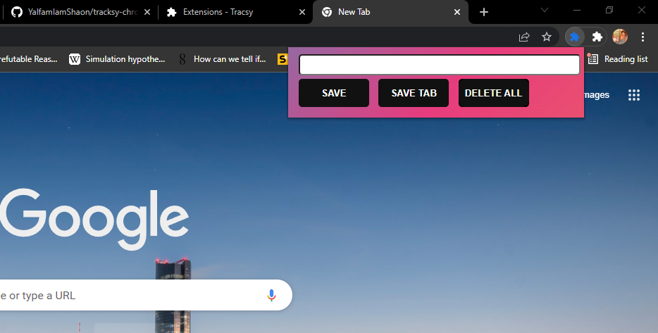

The Save Button will work when you paste any link to the box, and you save it to your local memory.

**2nd- Save Tab button**

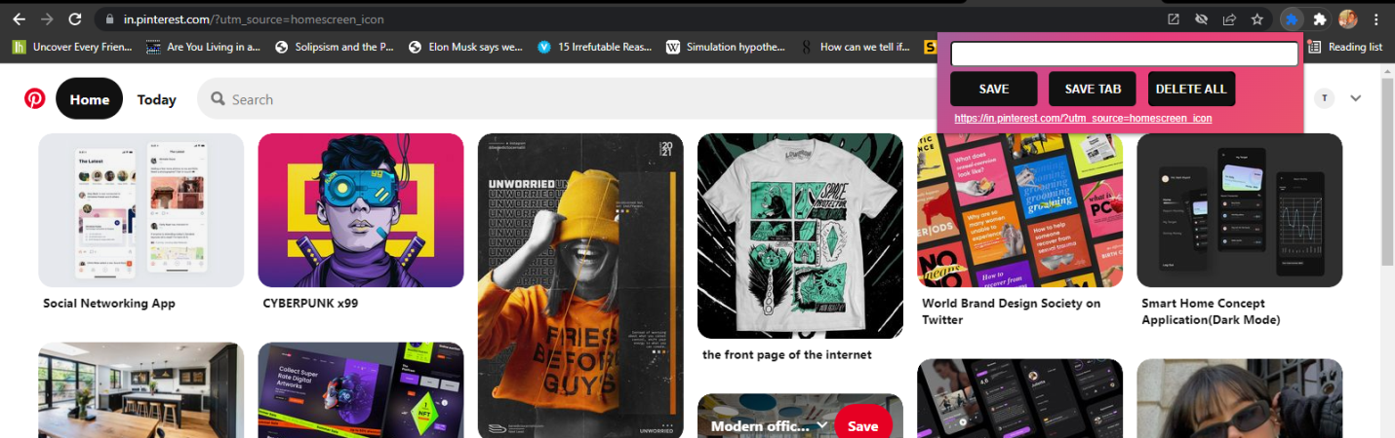

Whenever you go to any website or any important contact's LinkedIn profile or whatever, you can just click on Save Tab button to save the web address permanently.

**3rd - The Delete Button**

When you double click on this button, it will delete all your history.

***To use this Chrome extension. Just go to your Chrome Browser and upload the file in Extensions.***